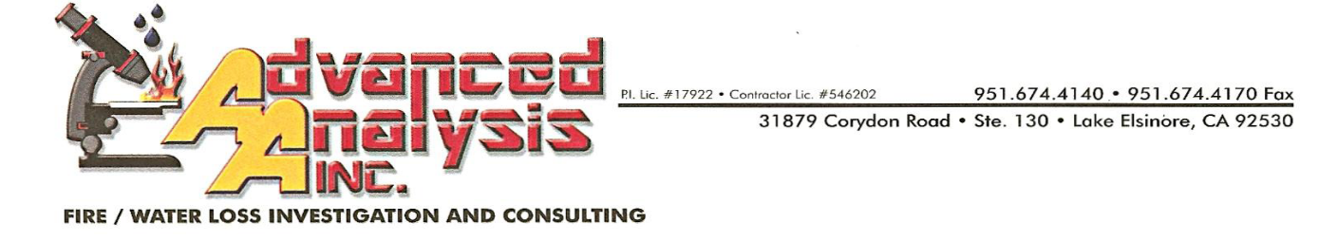
Request for Fire Incident and Investigation Reports

May 14, 2019 Case No: 19-214

Agency: Garden Grove Fire Department
City Clerk’s Office
Address: 11222 Acacia Parkway
Garden Grove, CA 92840

Attn: Records Division
Request: Fire Report
Type: Fire
Location: 9611 Maureen Drive
Garden Grove, CA 92841
Date of Incident: 5/9/19
Approximate time: 9:30 pm
Incident No: Unknown

To Whom It May Concern:

This firm has been retained by Farmers Insurance Company to conduct an origin and cause investigation into the above-stated fire loss. This letter is to request a copy of your fire incident and investigation report(s).

Please fax the report to 951-674-4170 or email to sue@advancedanalysis.net.

Sincerely,

Dan Bonelli, MCFI, CFEI, CFII, CVFI
Fire Investigator

Enclosures

DB/sr

